1)Remove the amount

2) Check the description (It appears multiple times.).

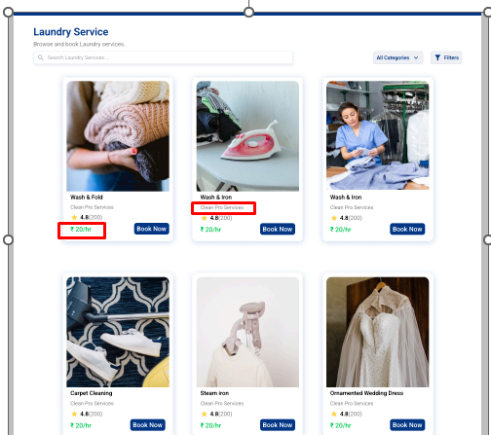

1) Check the dropdown design before and after login.

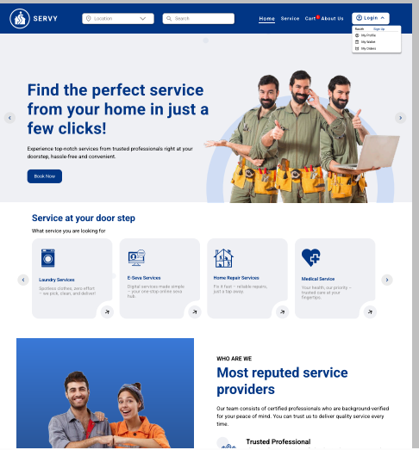

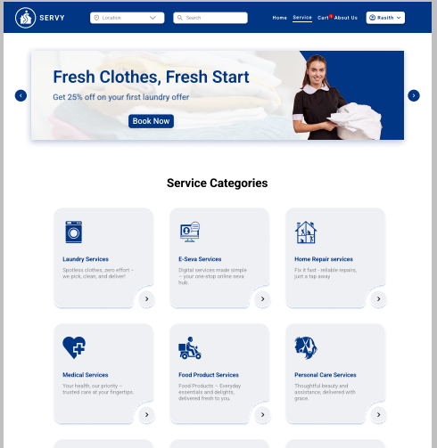

1)How can I save my Favourite screen?

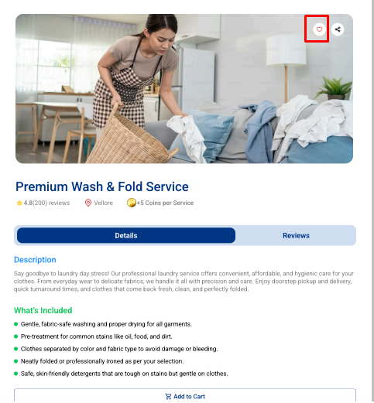

1)Check the Schedule Service, Book Service Screen

**Suggestion**: Merging the Schedule Service and Book Service screens depends on the user's point of view.

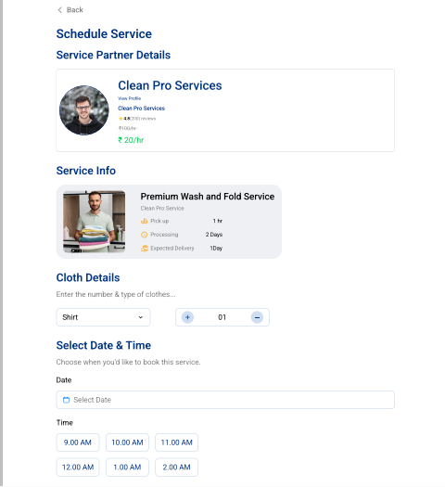

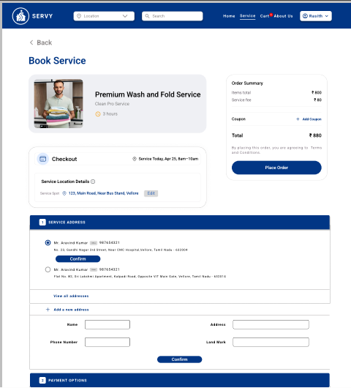

1)Remove the Cancel button

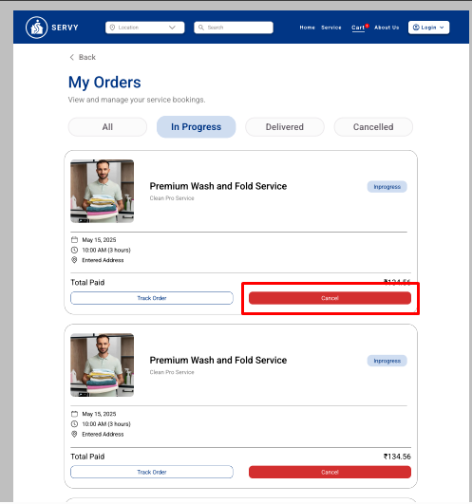

1)Status Screen 🡪 Remove the Cancel Booking

